**IoT-BASED AUTOMATION**

**of ELECTRICAL APPLIANCES**

in ECE Department Staffroom Using

ESP32 and Rainmaker Software

**Abstract**

This project aims to automate the control of electrical appliances, including 8 fans and 3 tube lights, in the ECE department staffroom of SRM TRP Engineering College. Utilizing an ESP32 microcontroller, an 8-channel relay module, and Rainmaker IoT software, the system allows remote operation of these appliances. Additionally, manual switches are incorporated to ensure functionality even in case of network unavailability or system failure. The Rainmaker software reflects real-time updates of the appliances' state when operated manually and provides information on device connectivity status, indicating whether the appliances are online or offline. Team members involved in the project include Abdul Muhsin A, Guna Sekar R, and Karthikeyan E.

**Block Diagram**

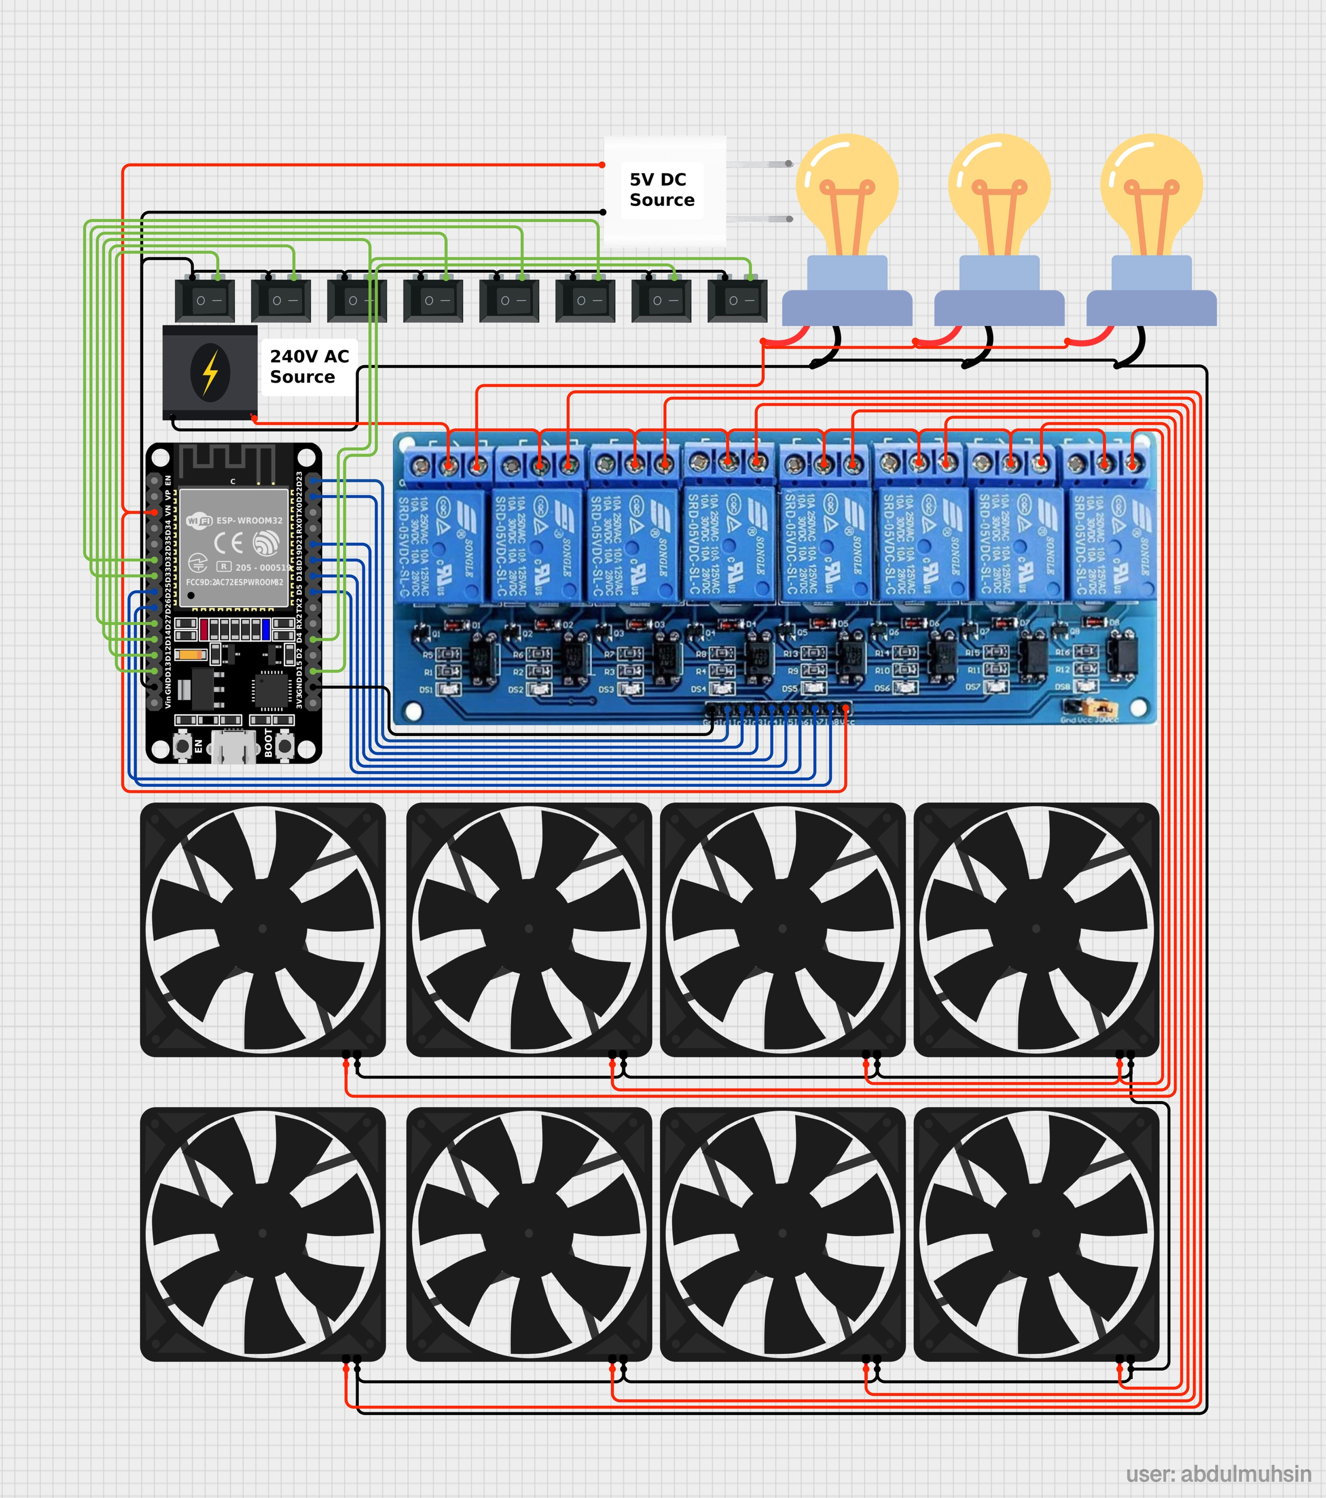

**Introduction**

* This project is designed to automate the electrical appliances in the staffroom of the ECE department, focusing on efficient control through IoT-based automation.
* The system leverages ESP32 for connectivity, along with an 8-channel relay module, to control fans and lights. It offers both remote and manual control, ensuring resilience in case of network issues.

**Objectives**

* Automate the control of 8 fans and 3 tube lights using IoT.
* Ensure manual control remains functional in case of system failure or network downtime.
* Provide real-time updates on appliance status via Rainmaker software.
* Allow multiple users to control the devices through shared access.

**Hardware Components**

* **ESP32 Microcontroller**: Responsible for managing Wi-Fi connections and controlling the relays.
* **8-Channel Relay Module**: Used to switch on/off the fans and tube lights.
* **Fans and Tube Lights**: 8 ceiling fans and 3 tube lights as the controlled appliances.
* **Manual Switches**: For parallel control in case of system or network failure.

**Software Components**

* **Rainmaker IoT Software**: Manages device control remotely, indicating online/offline status, and reflecting real-time updates when manual switches are used.
* **ESP32 Programming**: Configured to control relays, update appliance status, and communicate with Rainmaker.

**System Design**

* **ESP32 & Relay Integration**: ESP32 is programmed to interact with the relay module, toggling appliance states based on input from the Rainmaker app or manual switches.
* **Manual Override**: Appliances can be controlled manually, and the system ensures that any changes made via manual switches are reflected in the Rainmaker app.
* **Connectivity Monitoring**: Rainmaker software provides connectivity updates, displaying whether devices are online or offline along with the duration of the disconnection.

**Implementation**

* **Step 1**: Set up the ESP32 microcontroller and connect it to the 8-channel relay module.
* **Step 2**: Integrate manual switches to the appliances in parallel with the relay connections.
* **Step 3**: Configure the Rainmaker IoT platform to control and monitor the appliances.
* **Step 4**: Program the ESP32 to detect changes from both the IoT commands and manual switches, updating the appliance state accordingly.
* **Step 5**: Test the system for seamless operation during network outages or system failures.

**Features**

* **Remote Control**: Control appliances through Rainmaker software from any location.
* **Manual Control**: Use manual switches as a backup in case of system or network failure.
* **Real-Time Updates**: Changes made via manual switches are updated in the Rainmaker software.
* **Connectivity Monitoring**: Rainmaker indicates whether appliances are online or offline, showing the duration of any downtime.

**Software UI Overview**

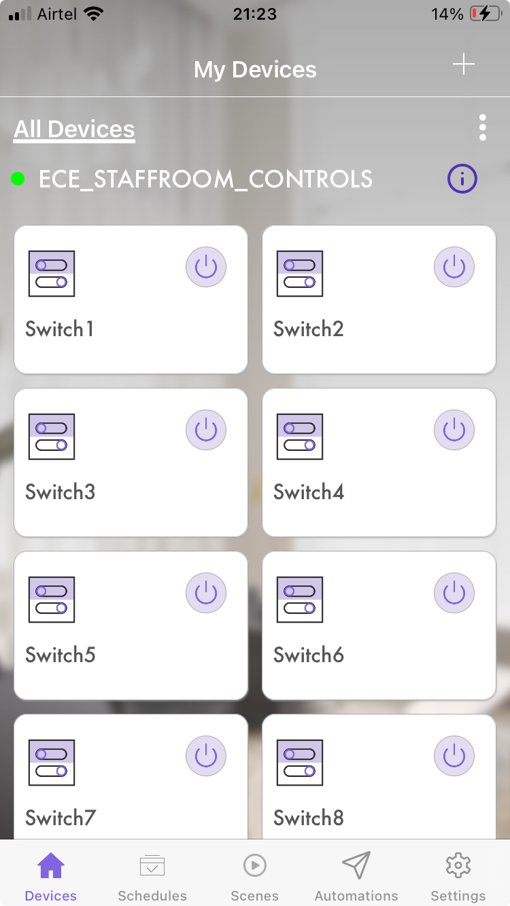

The Rainmaker software UI provides an intuitive and user-friendly interface for controlling the staffroom's 8 fans and 3 tube lights. Each appliance is represented by a labeled switch, allowing quick toggling through power icons. The system’s online status is indicated with a green dot, and the UI provides real-time feedback on appliance states. With easy navigation tabs for devices, schedules, scenes, and automations, the interface ensures efficient control and management of the system, including the ability to add more devices or users.

* **Real-Time Control**: Each switch reflects the current state of the connected appliance, providing instant control and feedback.
* **Online Status Monitoring**: A green dot indicates whether the system is online, ensuring connectivity is always visible.
* **Expandable Features**: The interface allows adding new devices or users, ensuring scalability.

**Conclusion**

The project successfully automates the staffroom’s electrical appliances, ensuring functionality and user control even during network outages. The integration of IoT with manual switches provides a reliable and flexible solution for everyday use.